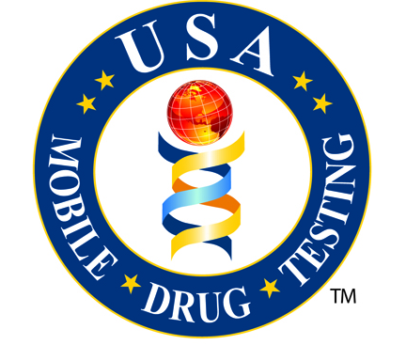
USA Mobile Drug Testing of the Treasure Coast
CREDIT CARD AUTHORIZATION FORM

Instructions

- Please complete this form by printing, legibly with a dark pen.
- Sign with the credit card holder’s signature on the line indicated.
- Include a photocopy of the front and back of the signed credit card.
- Fax this form and the photocopy of the signed credit card to our secure fax machine at 772-679-0122.

Credit Card Type: |  | VISA |  | MasterCard |  | Discover |  | American Express

Credit Card Number: |  |  |  |  |  |  |  |  |  |  |  | Security Number (back):

Expiration Date:
M M Y Y

Credit Card Billing Address:
Street |  | City
State |  | Zip

I, the undersigned, acknowledge that I am the authorized user of this credit card and I hereby authorize USAMDT to charge my credit card in the amount of:

WRITE DOLLAR AMOUNT (Numbers)

PRINT DOLLAR AMOUNT (Words)

By signing this authorization I acknowledge that I have read and agreed to all of the above information and warrant all information provided is true and correct.

Card Holder’s Printed Name

Card Holder’s Signature Date

Revised 7-11-13

